- Representational State Transfer refers to transferring "representations". You are using a "representation" of a resource to transfer resource state which lives on the server into application state on the client.

- REST stands for REpresentational State Transfer. REST is web standards based architecture and uses HTTP Protocol. It revolves around resource where every component is a resource and a resource is accessed by a common interface using HTTP standard methods. REST was first introduced by Roy Fielding in 2000.

- HTTP Methods
  - Head
  - Put
  - Post
  - Delete
  - Get

- In REST architecture, everything is a resource. These resources can be text files, html pages, images, videos or dynamic business data. REST Server simply provides access to resources and REST client accesses and modifies the resources. Here each resource is identified by URIs/ global IDs. REST uses various representations to represent a resource like text, JSON, XML. XML and JSON are the most popular representations of resources.

- A resource in REST is similar Object in Object Oriented Programming or similar to Entity in a Database.

Characteristics of a Good Representation
Understandability
Completeness
Linkablity

- HTTP Request

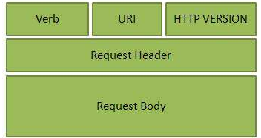
Verb- Indicate HTTP methods such as GET, POST etc.
URI- Contains the URI, Uniform Resource Identifier to identify the resource on server
HTTP Version- Indicate HTTP version, for example HTTP v1.1 .
Request Header- Contains metadata for the HTTP Request message as key-value pairs. For example, client ( or browser) type, format supported by client, format of message body, cache settings etc.
Request Body- Message content or Resource representation.
- HTTP Response
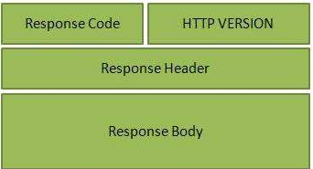
Status/Response Code- Indicate Server status for the requested resource. For example 404 means resource not found and 200 means response is ok.
HTTP Version- Indicate HTTP version, for example HTTP v1.1 .
Response Header- Contains metadata for the HTTP Response message as key-value pairs. For example, content length, content type, response date, server type etc.
Response Body- Response message content or Resource representation.

Constructing a standard URI
Use Plural Noun , Avoid using spaces, Use lowercase letters, Maintain Backward Compatibility, Use HTTP Verb

RESTful Web Services - Statelessness
a RESTful web service should not keep a client state on server. This restriction is called statelessness. It is responsibility of the client to pass its context to server and then server can store this context to process client's further request

Advantages of Statelessness
Following are the benefits of statelessness in RESTful web services
Web services can treat each method request independently.
Web services need not to maintain client's previous interactions. It simplifies application design.
As HTTP is itself a statelessness protocol, RESTful Web services work seamlessly with HTTP protocol.

